To generate the location of order, plant and seed, we made some assumptions.

1. We used NingBo city in ZheJiang province as the reference city. It is squared and the area is about 10000 km2
2. We assume that the order location follows Gaussian distribution and the number of orders is 100.
3. The plant is located at a remote place in the city
4. Decision maker based on the order distribution and the distance between order locations and plant location selects seed locations and container seed locations. Since the container use train and can reduce the cost, we set them to the farthest places.
5. Moreover, we assume that one seed location can serve only 20 customers. Therefore, we set the number of seed locations and container locations to four and two, respectively.

To generate the order location, firstly, we chose three points, which represent the most popular places. Then we add 10 times Gaussian noise to these three points. We also assume the point that is closest to the plant has more customers than other two points. Therefore, we generate 40 points to the closest point and 30 points to other 2 points separately. The figure of seed, plant and order locations can be seen below.

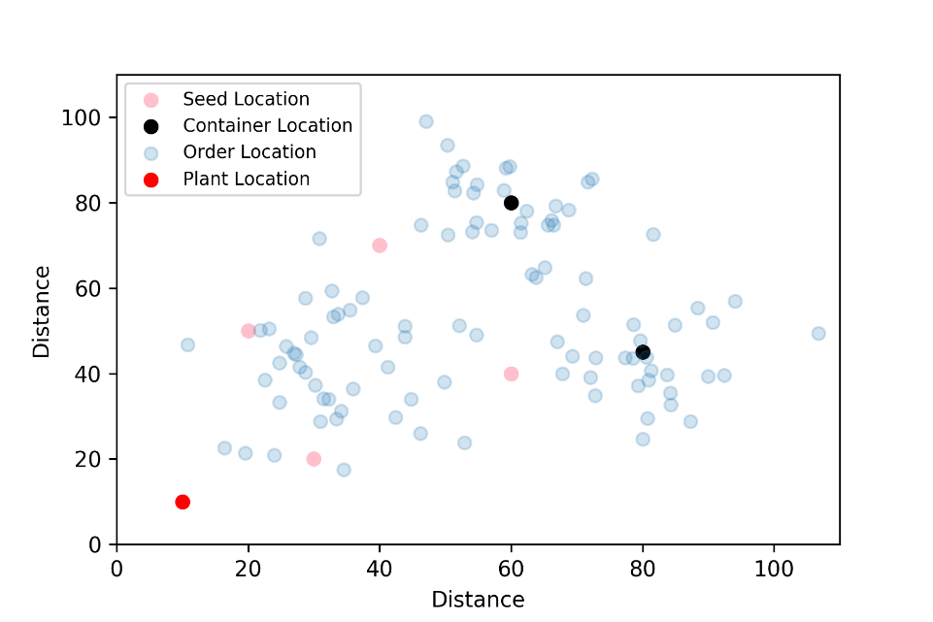

Fig. 1 Scatter plot of seed location, order location and plant location

From this dataset, we calculated $d_{ij}$ the distance between seed locations to order locations, $d_{0j}$ the distance between plant to seed locations, and $d_{0j}$ the distance between plant and order location.